  Motto: We Serve Negativity To Earn Positivity | Prepared by: Omurama Civil and Computer Engineering Company Limited  Contact us  Tell: +256705384084 \+256763689654  Email:omurama2021@gmail.com  :Nyesiga65@gmail.com  Website: omurama.com  OMURAMA CVIL AND COMPUTER ENGINEERING COMPANY LTD  Prepared by: Kekirunga patience Business Development Manager

Table of contents
Introduction…………………………………………………………………………………………………………………………
Background and Justification………………………………………………………………………………………………..
Objectives……………………………………………………………………………………………………………………………
Data Center Design Overview……………………………………………………………………………………………….
Proposed Infrastructure………………………………………………………………………………………………………
Budget Breakdown Summary……………………………………………………………………………………………..
Regulatory & compliance checklist…………………………………………………………………………………….
Request for Government Support………………………………………………………………………………………
Other Funding and Sustainability Strategies……………………………………………………………………….
Risk Management……………………………………………………………………………………………………………….
Long-Term Goals………………………………………………………………………………………………………………….
Expected Outcomes……………………………………………………………………………………………………………
Conclusion………………………………………………………………………………………………………………………..

Table of Contents
1. Cover page………………………………………………………………………………………………………………………………i
2. Table of Contents…………………………………………………………………………………………………………………..1
3. Vision, Mission & Core Values………………………………………………………………………………………………..2
4. Company History & Origin……………………………………………………………………………………………………..2
5. Leadership & Management……………………………………………………………………………………………………3
6. Organizational Structure………………………………………………………………………………………………..………4
8. Products & Services……………………………………………………………………………………………………………….5
9. Flagship Projects…………………………………………………………………………………………………………………….7
10. Target Market……………………………………………………………………………………………………………………...9
11. Partners & Collaborators……………………………………………………………………………………………………..9
13. Achievements & Milestones……………………………………………………………………………………….………9
14. Corporate Social Responsibility………………………………………………………………………………….…….10
15. Legal & Compliance…………………………………………………………………………………………………..………11
16. Human Resource……………………………………………………………………………………………………….……..11
17. Marketing & Communication…………………………………………………………………………………….……..12
18. Office & Infrastructure…………………………………………………………………………………………………….13
19. References & Client Portfolio…………………………………………………………………………………………..14
20. Signatures & Approvals……………………………………………………………………………………………………14

3. Vision, Mission & Core Values
Vision: To create Africa's technological independence through local innovation in AI, big data analytics, software development, and civil engineering solutions.
Mission: To provide secure, locally developed digital and infrastructure solutions that support national data sovereignty, employment, and innovation.
Core Values:
- Innovation
- Integrity
- Excellence
- Security
- Collaboration
- Sustainability

4. Company History & Origin
The dream of Omurama was born under the Omurama tree in Nganiko Village in 2007 when the founder, Nyesiga Henry, questioned how one could communicate from rural villages to Kampala. The interest grew into a passion for technology and led him to Makerere University in 2018, where he studied AI, cybersecurity, web design, and cloud computing.
Inspired by Google's "Attention Is All You Need" research in 2020, Henry and his colleagues founded Omurama in 2021 to counter Uganda and Africa's dependence on foreign technology by building robust local software, AI models, and infrastructure.

5. Leadership & Management

Name | Position | Qualification | Role
Nyesiga Henry | Managing Director, Omurama | BSc. Information Systems and Technology, Makerere University | Project Lead & System Architect
Kekirunga Patience | Business Development Manager | BA Business Administration | Strategic Partnerships & Proposal Design
Ahebwe Narath | IT Engineer | BSc. Computer Science | Software Development & Integration
Issac Akimu | Civil Engineer | BEng. Civil Engineering | Infrastructure and Data Center Planning
Kemegish Ruth | Accountant | BCom Accounting | Financial Management
Twesigye Innocent | Data Analyst | MSc. Data Science | Data Analytics & AI Modeling
Lucky Paul | Cybersecurity Specialist | CEH Certified | Security Design & Audits

- Managing Director: Nyesiga Henry
- Senior Management & Department Heads:
- Natukunda Juliet – Operations
- Ampire Julian – Administration
- Lucky Paul – IT Support
- Ahebwe Narath – Data Engineer
- Isaac Akimu – Civil Engineer
- Kemegish Ruth – Accountant
- Kekirunga Patience – Business Development
- Twesigye Innocent – R&D Support
- Wycliffe – ICT Officer
- Atono Sarah - Cloud Computing Engineer
- Sekubuge Bashir-Cyber Engineer
- Mukanda Rovence- Hand of Research Department
Plus 10 additional employees in software development, cyber security, data engineering, and construction teams.

6. Organizational Structure
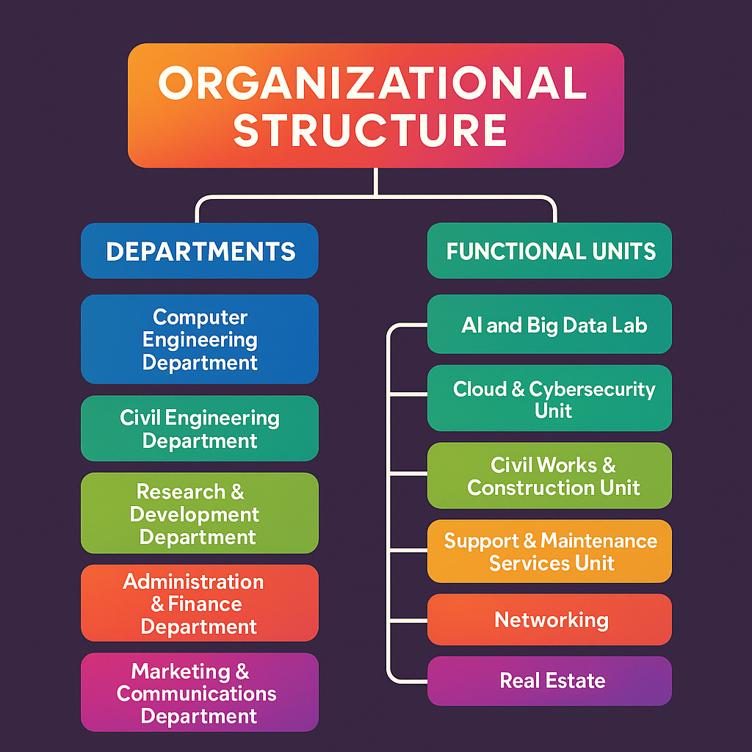

Departments:
- Computer Engineering Department
- Civil Engineering Department
- Research & Development Department
- Administration & Finance Department
- Marketing & Communications Department

Functional Units:

- AI and Big Data Lab
- Cloud & Cyber security Unit
- Civil Works & Construction Unit
- Support & Maintenance Services Unit

7. Strategic Aim
Omurama aims to break Uganda's over-dependence on foreign technology and foster national data privacy by:
- Developing and hosting local software and AI solutions.
- Deploying local cloud computing infrastructure.
- Creating over 5,000 job opportunities in Uganda and East Africa.
- Providing low-cost digital marketing solutions.
- Empowering digital transformation in Africa.
8. Products & Services
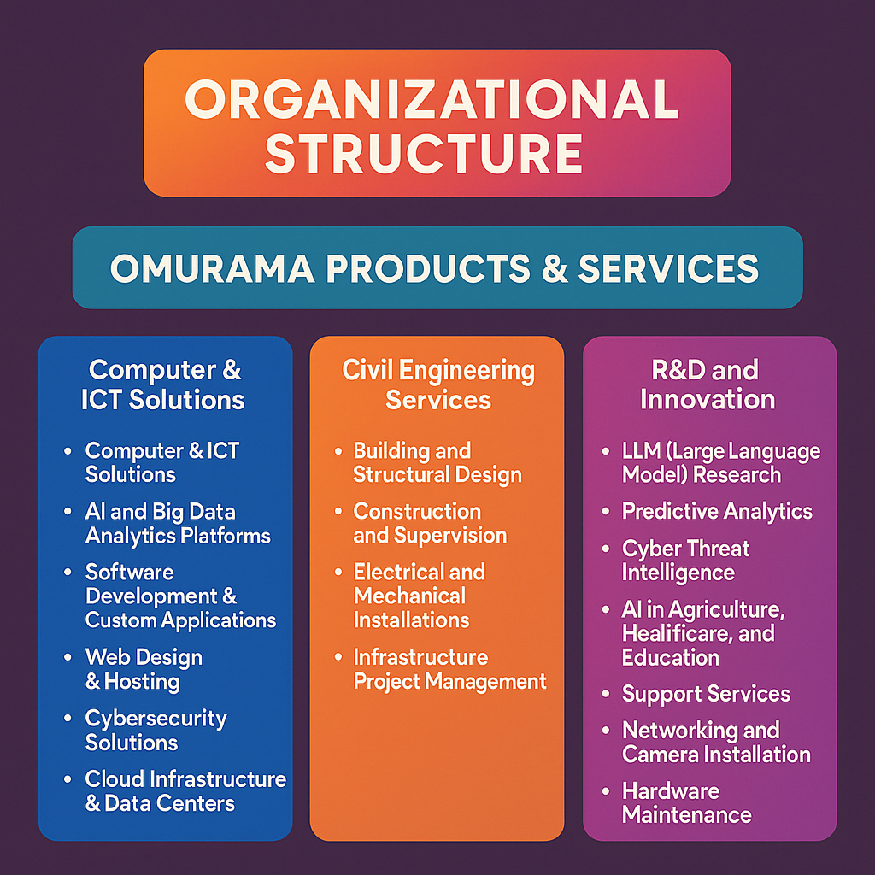

- Computer & ICT Solutions
- AI and Big Data Analytics Platforms
- Software Development & Custom Applications
- Web Design & Hosting
- Cyber security Solutions
- Cloud Infrastructure & Data Centers
- Computer Vision & Algorithm Control
- Civil Engineering Services
- Building and Structural Design
- Construction and Supervision
- Electrical and Mechanical Installations
- Infrastructure Project Management
- R&D and Innovation
- LLM (Large Language Model) Research
- Predictive Analytics
- Cyber Threat Intelligence
- AI in Agriculture, Healthcare, and Education
- Support Services
- Networking and Camera Installation
- Hardware Maintenance
- ICT Training and Capacity Building

9. Flagship Projects
Project Name | Description | Sector
ASA (Artificial Soldier Assistant) | Ai-powered defense decision support & cybersecurity Systems | Security & Defense
CIVA (Crime Intelligence Virtual Assistant) | AI-powered crime intelligence, threat detection & fraud prevention. | Security, Police, Ministry of Internal Affairs
DeLand | Social network & e-commerce platform | ICT, Business, Public
0Page | Web access and content solution platform | ICT
AI Data Center Project | Local hosting & big data infrastructure | Cloud, National Security
Omurama Search | Localized search engine for Ugandan and African digital resources | ICT, Public

10. Target Market
- Intelligence agencies in Uganda and Africa
- Government Agencies and Ministries
- Healthcare facilities
- Agricultural industry
- Financial institutions
- Educational institutions
- Private entities and individuals

11. Partners & Collaborators

- Rupid-Ug
- Ministry of ICT and National Guidance
- Meta
- Google
- Hugging Face
- YOLO
- Oracle
- IBM

12. Strategic Goals (2025–2030)
- Establish the first fully functional AI & Big Data Data Center in Uganda.
- Develop a National AI Cloud Infrastructure.
- Expand service coverage to all countries in the East African Community.
- Employ and train 5,000+ young Ugandans in technology.
- Create a National Cybersecurity Operations Center powered by Omurama AI.

13. Achievements & Milestones

- Founding member contributions to AI research in Uganda.
- Early collaborations with Makerere University and Rupid-Ug.
- Successful ASA and CIVA system prototypes.
- Omurama Search engine beta development.
- Developing R&D capabilities.

14. Corporate Social Responsibility

- Youth training in ICT skills.
- Equipping rural schools with basic digital infrastructure.
- Promotion of environmental sustainability using digital innovation.

15. Legal & Compliance

- Registered in Uganda.
- URSB and URA regulations compliant
- ISO certification for cybersecurity and AI development in the pipeline.

16. Human Resource

- Current Team: 20 employees
- Projected Growth: 100 employees by 2027
- Core Skills: AI engineering, big data, cloud computing, software development, civil works, accounting, and research.

17. Marketing & Communication
- Digital marketing campaigns across East Africa
- Presence at AI and technology exhibitions
- Social media presence
- Client engagement strategy for government and private sector

18. Office & Infrastructure
Head Office: Najjanakumbi, Kampala
AI Research Lab (in plan)
Local cloud hosting environment (under development)
Secure data infrastructure


19. References & Client Portfolio
- Ministry of ICT and National guidance
- Makerere University
- Rupid-Ug
- Individual private clients
- Early-stage government partnerships

20. Signatures & Approvals

Prepared by:
Kekirunga Patience
Business Development Manager
Tell: 0783786101

Approved by:
.................................................................
Nyesiga Henry
IT Specialist & Big Data Engineer
Omurama Civil and Computer Engineering Company Ltd
Najjanakumbi, Kampala
Tel: +256705384084 or +256763689654
Email: omurama2021@gmail.com
Website: Omurama.com

